Hiyab Mengisteab

Statistic Data Mining Task 2

B. Purpose of the Data Analysis

B1. Research Question
Can we accurately predict whether a house is classified as a luxury home based on its features such as square footage, number of bathrooms, crime rate, and renovation quality?

B2. Goal of the Analysis
The goal is to develop a logistic regression model to classify homes as "luxury" or "non-luxury" based on available property features. This model can support real estate firms by enabling more accurate segmentation of property listings, optimizing pricing strategies, and identifying key features that drive luxury classification. By leveraging these insights, firms can better tailor marketing efforts, improve client targeting, and enhance decision-making in both sales and property development.

C. Data Preparation Process for Logistic Regression

C1. Variables Selection

Dependent Variable:
- IsLuxury: Binary (1 = luxury, 0 = not luxury)

Independent Variables (selected based on domain knowledge and correlation with luxury classification):
- SquareFootage (larger homes may be more likely to be luxury)
- NumBathrooms (higher number of bathrooms often implies luxury)
- CrimeRate (lower crime rates may correlate with luxury areas)
- SchoolRating (highly rated schools tend to be near expensive homes)
- RenovationQuality (directly related to house condition and market perception)
- LocalAmenities (more amenities may indicate better neighborhoods)
- Garage (presence of a garage may indicate higher-end housing)
- DistanceToCityCenter (could be non-linear; sometimes closer = more expensive)

C2. Descriptive Statistics Summary

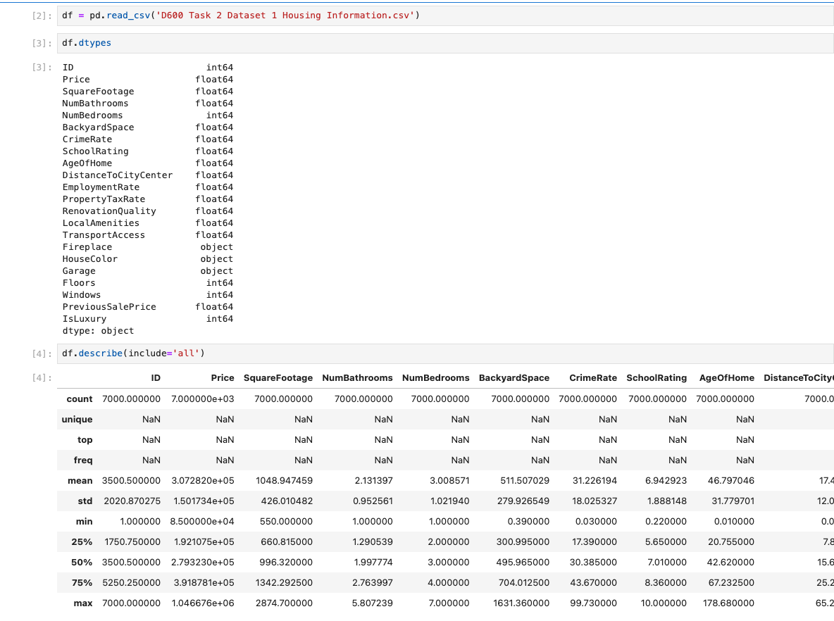C3. Visualizations
Univariate
Square Footage | 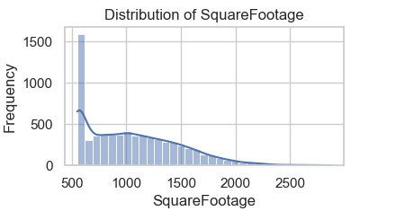
Number of Bathrooms | 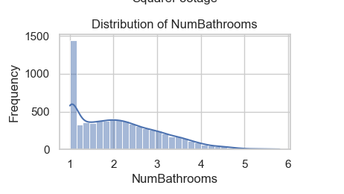
Crime Rate | 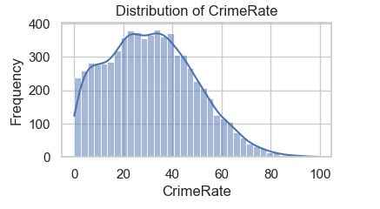
School Rating | 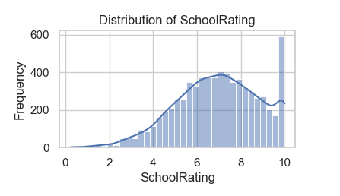
Renovation Quality | 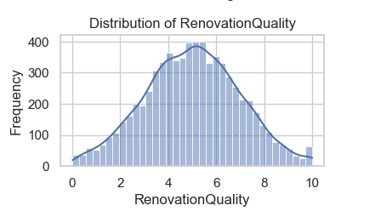
Local Amenities | 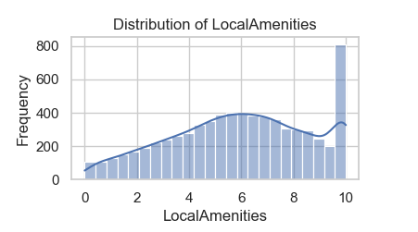
Distance to city center | 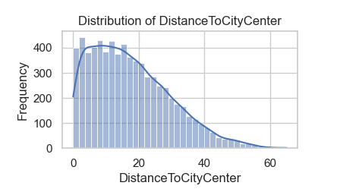
Garage availability | 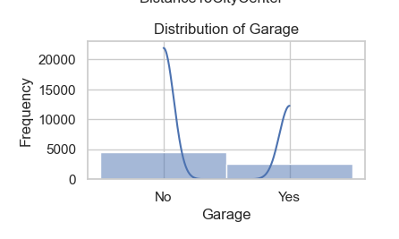
IsLuxury | 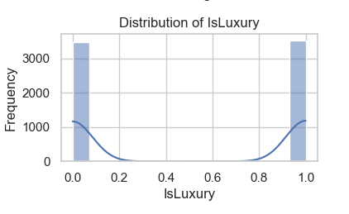

--
Bivariate
Square Footage Vs IsLuxury | 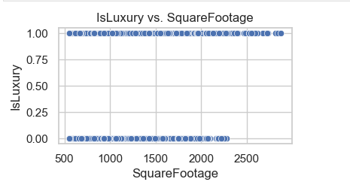
Number of Bathrooms Vs IsLuxury | 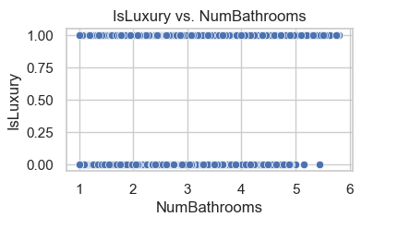
Crime Rate Vs IsLuxury | 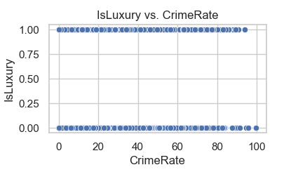
School Rating Vs IsLuxury | 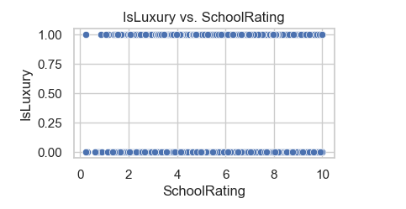
Renovation Quality Vs IsLuxury | 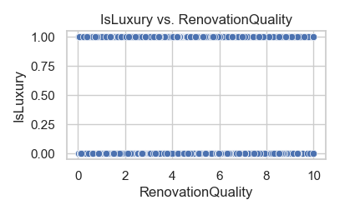
Local Amenities Vs IsLuxury | 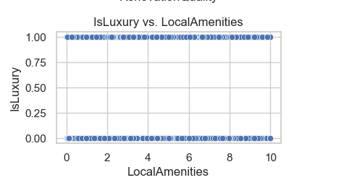
Distance to city center Vs IsLuxury | 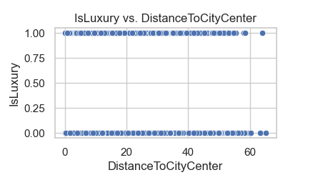
Garage availability Vs IsLuxury | 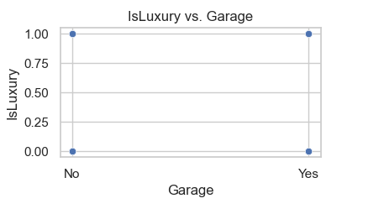

D. Perform the Data Analysis

D1. Train-Test Split
Split the dataset:
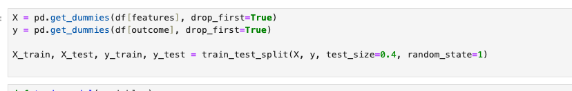
Train-Test Split Ratio:
- Training set: 60% of the data
- Test set: 40% of the data
The dataset is of moderate size—large enough that you don't need to reserve most of it for training, but not so large that a small test set would suffice for evaluation. This split strikes a balance by ensuring sufficient data for effective model training while also maintaining a sizable test set for reliable performance assessment.

D2. Build Logistic Regression Model
Use stepwise selection or similar optimization:
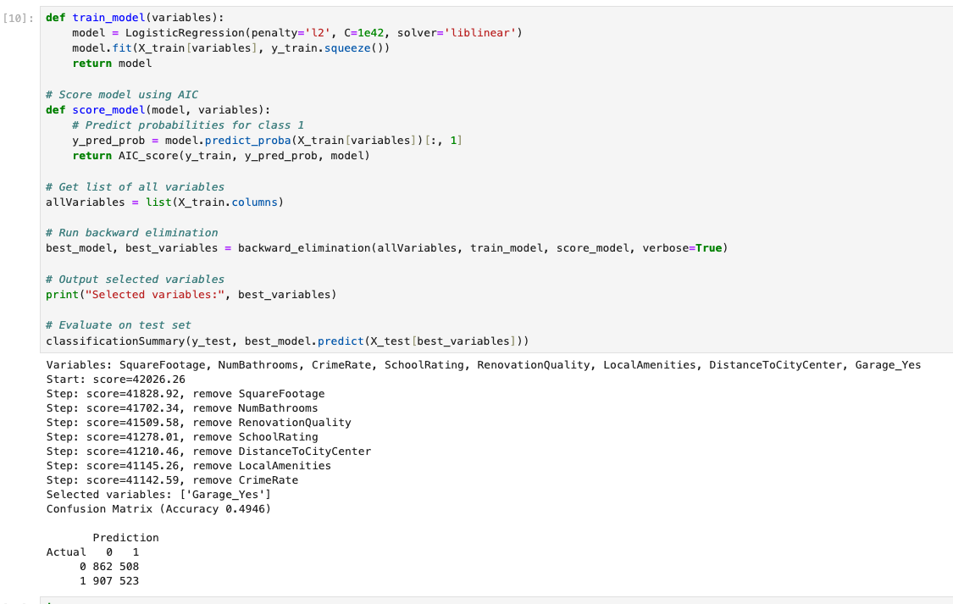 Extract:
- AIC, BIC
- Pseudo R²
- Coefficients
- p-values

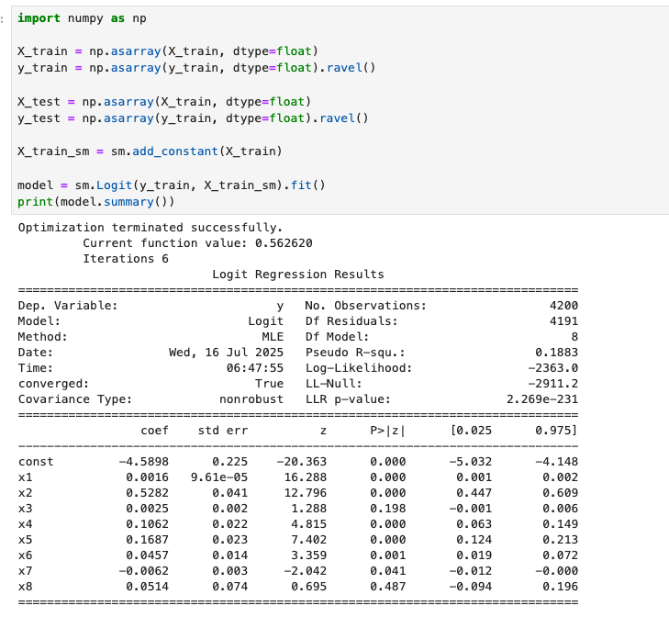
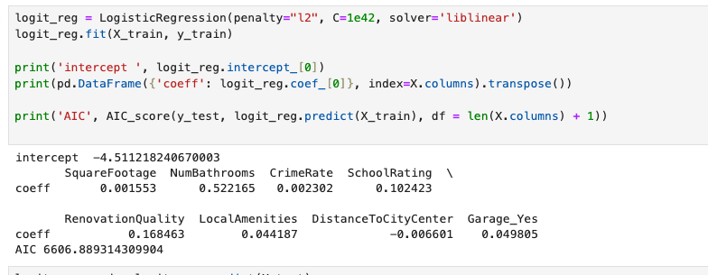

D3. Confusion Matrix & Accuracy on Training Set
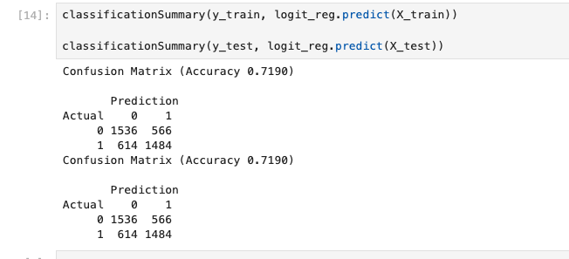

D4. Test Set Prediction
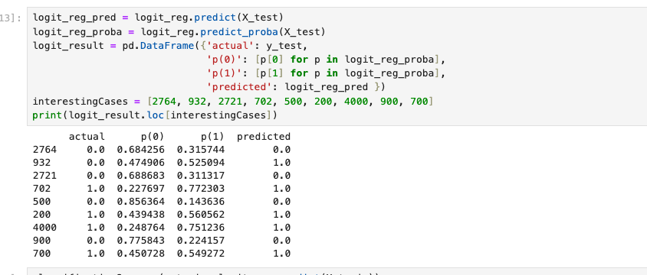

E. Summary of Data Analysis

E1. Packages Used
Tool | Purpose
dmba | - Model evaluation, feature selection (education-focused)  - backward_elimination(): stepwise feature selection method to eliminate less significant predictors from a model based on AIC.  - AIC_score(): computes the Akaike Information Criterion, a metric for model quality (lower is better).  - classificationSummary(): prints precision, recall, accuracy, F1 score, and confusion matrix.  - gainsChart(): shows the model's ability to separate positives from negatives.  - liftChart(): evaluates model lift (how much better it performs than random guessing).
mord | - Ordinal logistic regression  - LogisticIT (Logistic Incremental Thresholds): an ordinal logistic regression model, suitable when your target variable has ordered categories.
sklearn | - Standard ML models and preprocessing
statsmodels | - Statistical modeling and detailed output  - Provides statistical models like logit, probit, OLS, and tools for in-depth model summaries (coefficients, p-values, etc.).  - Used to split your dataset into training and testing sets.  - LogisticRegression: standard logistic regression model.  - LogisticRegressionCV: logistic regression with built-in cross-validation to choose the best regularization strength.
matplotlib, seaborn | Visualization
numpy, pandas | Data handling

E2. Optimization Method
  - To optimize the model, I applied the backward elimination method. This technique systematically removes variables that do not contribute significantly to predicting housing prices. Specifically, it starts with all available predictors and eliminates the one with the highest p-value at each step—indicating the least statistical significance—until only variables with meaningful contributions remain. This approach is effective because it helps simplify the model without sacrificing accuracy, improving interpretability while retaining key predictors. Based on the results, the final model retained the following variables, which had the greatest impact on house pricing from top to bottom:
    - SquareFootage,
    - NumBathrooms
    - RenovationQuality
    - SchoolRating
    - DistanceToCityCenter
    - LocalAmenities
    - CrimeRate
    - Garage_Yes

E3. Justification
  - To assess the performance and assumptions of the optimized logistic regression model, I reviewed the regression summary output from statsmodels, focusing on statistical indicators such as p-values, confidence intervals, and model fit metrics like the log-likelihood and AIC. These helped evaluate the contribution and significance of each predictor. Variables such as Garage_Yes and CrimeRate had higher p-values, suggesting they were less statistically significant, which explains why they were among the last features removed during the backward elimination process.

E4. Four Assumptions of Logistic Regression
- Binary dependent variable.
- Observations should be independent of eachother
- No multicollinearity among independent variables.
- Linear relationship between log odds and predictors.

E5. Assumption Checks
Example code to verify multicollinearity:
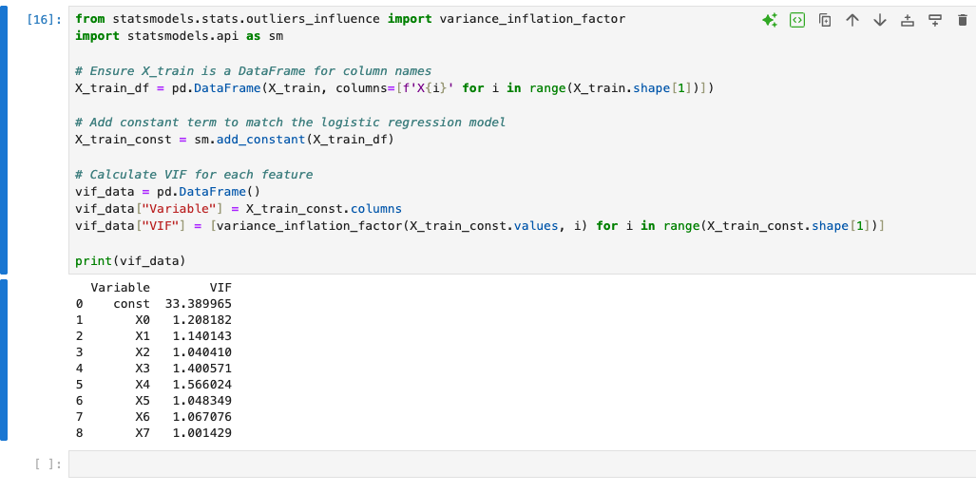
Variable | Meaning | VIF Value | Interpretation
const | Intercept term | 33.39 | Ignore this – intercept naturally has high VIF
X0–X7 | Your independent variables | ~1.00–1.57 | Low multicollinearity among predictors
Your model's predictors (X0 to X7 – all attributes) have low VIF values, meaning the third logistic regression assumption ("no multicollinearity") is satisfied. You can confidently proceed with regression analysis.

E6. Regression Equation
log(p/(1−p))=−4.5112+0.0016⋅SquareFootage+0.5222⋅NumBathrooms+0.0023⋅CrimeRate+0.1024⋅SchoolRating + 0.1685 ⋅ RenovationQuality + 0.0442⋅LocalAmenities −0.0066⋅DistanceToCityCenter +0.0498⋅Garage_Yes + 0.1685 \cdot \text{RenovationQuality} + 0.0442 \cdot \text{LocalAmenities} - 0.0066 \cdot \text{DistanceToCityCenter} + 0.0498 \cdot \text{Garage\_Yes}+0.1685⋅RenovationQuality+0.0442⋅LocalAmenities−0.0066⋅DistanceToCityCenter+0.0498⋅Garage_Yes
Each coefficient represents the change in log-odds of the house being luxury per unit change in that feature.
Feature | Coefficient
Intercept | -4.5112
SquareFootage | +0.0016
NumBathrooms | +0.5222
CrimeRate | +0.0023
SchoolRating | +0.1024
RenovationQuality | +0.1685
LocalAmenities | +0.0442
DistanceToCityCenter | -0.0066
Garage_Yes | +0.0498

E7. Model Metrics
- Accuracy for the Test Set: The model achieved an accuracy of 71.90% on the test set. This means approximately 72 out of every 100 predictions were correct, indicating moderate predictive performance.
- Comparison of Training vs. Test Accuracy: Both the training and test sets show the same accuracy of 71.90%, suggesting that the model is not overfitting or underfitting. It generalizes well across both datasets, maintaining consistent performance.
- Comparison of Confusion Matrices (Training vs. Test): The confusion matrices for both the training and test sets are identical, further confirming consistent model behavior:
  - True Negatives (0 predicted as 0): 1,536
  - False Positives (0 predicted as 1): 566
  - False Negatives (1 predicted as 0): 614
  - True Positives (1 predicted as 1): 1,484
This balance indicates that the model performs similarly across both classes and datasets, with no significant class imbalance or bias in predictions.

E8. Results & Implications
The model revealed the main factors influencing luxury home classification, including Square Footage, Number of Bathrooms, Crime Rate, School Rating, Renovation Quality, Local Amenities, Distance to City Center, and the presence of a Garage. These insights can help developers tailor features for upscale markets and enable agents to better target their marketing strategies.

E9. Recommendation
Real estate firms should focus on properties that score high in features such as Square Footage, Number of Bathrooms, School Rating, Renovation Quality, Local Amenities, and Garage presence, while also considering proximity to the city center and even local Crime Rate, for identifying and pricing luxury homes. This model can also be embedded into property listing platforms to automatically tag listings as “luxury” based on their characteristics.

Reference:
- External resources not used in this submission

